Introduction
This resource has been produced in the following format:
- a teacher’s pack, including teachers’ notes and learner resources to download

Overview
Structure, learning hours and delivery context
This resource is designed to assist ESOL learners who would like to join a vocational course whilst in prison. The unit provides an introduction to commonly heard terminology associated with the vocational areas of the gym, the gardens and hairdressing. Activities are designed to enable learners to become familiar with common practices based around these areas which should assist them, if they decide to join one of the courses.
- The resource is divided into 3 units:
Unit 1 Working in horticulture
Unit 2 Being a fitness instructor
Unit 3 Hairdressing
- The resources developed may be used independently or as one linked topic over several sessions.
- Timings are flexible and teachers can adapt the resource to suit their learners , break down the units into smaller chunks of learning and build in revision as required

Level: Entry level 1-3 / National 2 - 4 / CEFR A1 - B1

Pre-vocational training

Unit 1

Working as a gardener

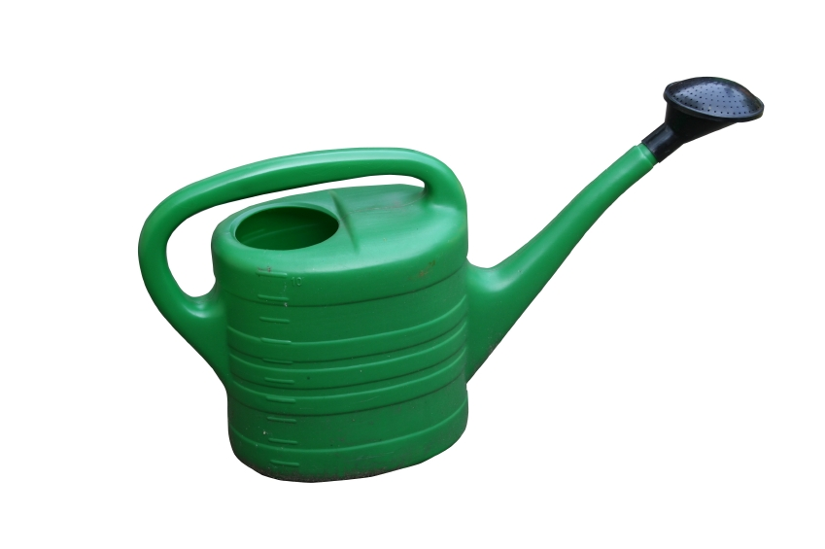



Contents

Unit 1 Working as a gardener: teachers’ notes

Unit 1 Working as a gardener: transcript

Unit 1 Working as a gardener: answers

Unit 1 Working as a gardener: resources

Unit 1 Working as a gardener: audio TP_Prevoc_U1_gardener.mp3

Copyright - please read
All the materials on these pages are free for you to download and copy for educational use only. You may not redistribute, sell or place these materials on any other website without written permission from the British Council. If you have any questions about the use of these materials please email us at: esolnexus@britishcouncil.org

Unit 1 Working as a gardener

This unit has been designed to introduce learners to vocabulary and grammatical structures associated with gardening and horticulture. Learners will become familiar with commonly heard gardening terms, collocations and imperatives relating to gardening. Speaking and listening activities involve learners listening to and giving instructions.

Entry level 1-3 / Scottish National 2 - 4 / CEFR A1 - B1
Time: 90 minutes + Timings are flexible and teachers can break down the units into smaller chunks of learning and build in revision as required

Aims
- To introduce language needed to progress to a horticulture course
- To develop vocabulary associated with gardening and horticulture
.
Objectives
All learners will be able to:
- Identify 6 pieces of garden equipment.
- Identify adjectives in a text
- Identify common plants
- Sequence instructions
- Use common collocations associated with gardening

Learners at Entry 2 / National 3

- Sequence a list of instructions for performing a horticultural task
- Use imperatives for giving and following instructions
- Read course information.

Preparation
You will need:
Resource 1 Tool vocabulary - one copy cut up per pair.
Resource 2 Present continuous of gardening verbs. One copy per 3-4
learners
Resource 3 Tool purpose - one for each beginner/E1/N2 learner
Resource 4 Questionnaire - one copy for each learner
Resource 5a Planting seeds - one copy for each learner
Resource 5b one copy for each beginner/E1/N2 learner
Resource 6a Listening activity - one copy per learner
Resource 6b Listening activity - one copy per beginner/E1/N2 learner
Resource 7a Imperative cards, cut up - one set for each pair of learners
Resource 7b Cup of Tea instructions - one copy for each beginner/E1/N2 learner
Resource 8 Imperatives to give advice - one cut up set of cards for each 3-4 learners
Resource 9a one copy for each learner
Resource 9b one half to each learner
Resource 10 word search for cell work

Consider
- If there are horticulture courses or gardening schemes run in your prison ask about the level of English learners need to access these courses and collect leaflets or course information sheets to give to interested learners.
- Invite a tutor or someone who does gardening to speak to your learners about what they could learn and do on the course.
- Other useful materials available online e.g. from the Excellence Gateway yhttp://rwp.excellencegateway.org.uk/Embedded%20Learning/Vocational/Horticulture/ BBC Skillswise http://www.bbc.co.uk/skillswise/worksheet/ma32maps-l1-w-garden-plans
Procedure
Warm up Activity – identify garden equipment (10 minutes)
- Elicit names of any gardening equipment the learners know.
- Show equipment picture on the unit cover and ask learners to try to identify it.
- Ask learners to work in pairs using resource 1 to match the names of the equipment to the pictures. Give lower-level learners fewer pictures to match and support them.
- Drill the vocabulary for pronunciation.
Activity 1 – Gardening tasks (10 minutes)
- Using the images in resource 1, elicit the purpose of each tool by asking – ‘What do you use a trowel for?’ Elicit ‘to dig’ or ‘digging’
- Show resource 2 and ask what they are doing. Elicit ‘He is/They are mowing/digging etc.
- Teach pruning is the action of cutting back branches; weeding is the action of pulling up weeds and that they are unwanted plants.
- Revise present continuous; verb to be with ‘ing’.
- Give resource 3 to each pair of lower-level learners. They take it in turns to ask ‘What do you use a …… to do?’ The other says ‘to dig, prune etc.’ and ticks the correct purpose for the tool, if they agree.
Differentiation
- Higher level learners use resource 1 and work in pairs, asking alternately – ‘What is a ..... used for?’ Point out that secateurs is a plural form so the correct form would be ‘What are secateurs used for.’
- Elicit the passive response – Secateurs are used for pruning. Highlight the difference between the active and passive. The active – I/you use secateurs for ...
- Support and monitor, correcting errors where appropriate.
Activity 2 – What I like doing (10 minutes)
- Elicit what jobs they like doing around the prison. Do they like working outside? Explain that after enjoy we also use the ‘ing’ form; ‘I enjoy gardening.’ After like we can use either ‘ing’ or ‘to’ I like to water the plants outside my window / ‘I like watering plants’. This should be distinguished from the present continuous.
- Hand out resource 4 – questionnaire. Elicit the question that they must ask – ‘Do you like + ing/to
- Learners work in pairs asking and answering questions.
- Ask learners to feed back to you to check use of 3rd person singular. Maria likes weeding. Bart doesn’t like working outside.
Activity 3- Instructions (15 minutes)
- Following instructions will be a key component of any course and very important in vocational courses. Remind learners of instructions you give them e.g. ‘Listen to the audio, Work in pairs, Tick the right answer’. Write examples on the board.
- What do they notice about the position of the verb – underline the verbs for added stress? Elicit that the verb comes first and is called the imperative.
- Ask for other examples of imperative verbs e.g. Put litter in the bin’.
- They are now going to read instructions for planting seeds.
- Find out how much they know about planting seeds and elicit or pre-teach key vocabulary: What do you need to plant seeds? Accept other words but tell them the words they need that are of similar meaning e.g. compost if they say soil or seed tray if they say pot.
- Hand out resource 5a to each pair of higher-level learners and 5b to lower-level pairs.
- Learners using 5a sequence the words to make sentences, and then sequence the sentences. Lower-level learners complete 5b and just sequence the sentences.
- Read out the sentences for learners with limited English literacy and support them to decide on the right order.
Activity 4 - Following Instructions (15 minutes)
- Explain to learners that they are now going to listen to an audio about following instructions.
- Hand out resource 6a or 6b.
- Play the audio and ask learners to complete question 1.
- Feedback and then play the audio again for learners to complete the remaining questions.
- Tell learners that they are now going to write some instructions.
- Hand out the instruction cards, (Resource 7a) one set for each pair of learners.
- Each learner takes a card and makes an instruction with the imperative on the card – e.g. Learner A takes the word ‘put’ and can make a sentence, ‘Put the weeds in the bin.’ Learners then write the instructions.
Differentiation
- Give lower-level learners fewer words and work with them to give oral instructions using some of the images from the resources.

Optional
- Lower level learners can use Resource 7b to write create instructions for making a cup of tea. If they complete this quickly, see if they can use the surplus imperatives to form correct collocations.
Activity 5 – Giving Instructions (15 minutes)
- Explain to learners that we use the imperative form when we tell people what to do or give advice e.g., –‘I want to join the horticulture class, what should I do?’ ‘Put in an app to education.’
- They are now going to give advice to some learners who have horticultural problems.
- Hand out the cards from Resource 8 – (one set to each group of 2-3 learners.)
- Differentiation - The first few problems are suitable for lower level learners.
- Each learner reads from the card and gives advice. The group can either agree or disagree.
- Read out each problem and invite the response from one of the groups. Ask another group if they agree with the way the answer has been said. Give the first speaker the chance to self-correct if necessary. Don’t over correct but not any issues you can address in a future session.
Activity 6 – Reading (15 minutes)
- Ask learners if they would like to work in horticulture on release.
- Elicit what jobs/areas they could work in.
- Tell learners that they are now going to read about finding a gardening job.
- Lower level readers are going to read about gardening jobs they can do in the prison
- Give Resource 9a to higher level learners to read the text in pairs and answer the questions.
- For Resource 9b, pre teach some vocabulary; lettuce, daffodils. Learners work in pairs. Hand one half of the worksheet to each learner. Learners form questions to ascertain the missing information – Where does he work? What is he planting?
Cooler – I went to the tool shed and asked for a.... (10 minutes)
- Reinforce learning by playing a memory game. You could do this as a whole class activity or as small groups at the same level of proficiency.
- Start the game by saying - ‘I went to the tool shed and asked for a ...(name of item from resource 1)
- Learner 1 then repeats your sentence adding on an additional item from resource 1. The next learner repeats the previous, and then adds on a further item.
Differentiation
- Lower level learners work together with half of resource 1 to remember.
- Higher level learners not only have to remember the items in the correct sequence, but also to give their purpose.

Cellwork Activity
- Hand out resource 10 word search to all learners. Check understanding of compost (dead plant matter used to make plants grow) and tell them that one of the words runs diagonally.

Transcript
Hi, I’m Andy. I teach horticulture to prisoners here at HMP Pinewood. I tell my learners to study horticulture so they can get a job. There are lots of jobs you can do.
- Work in a garden centre or for a company, mowing lawns and cutting hedges.
- Start up your own business doing local gardening work. Local councils also have a works department that cut trees and mow verges by the roadside. They also look after all the public parks, mowing the grass and planting up the flower beds.
So here are a few tips to help you get a job in horticulture.
- Write a good CV. Include in it all the horticultural work you did when you were in prison. If you can use a lawnmower, say so. It means your employer won’t have to spend time and money teaching you.
- Get a qualification. The horticulture course is long, but you will have a qualification that you can use outside.
- Use the VC, if you have it at your prison, to keep an eye on horticultural jobs.
- Make a note of the companies who are advertising and then write to them when you are out.
I hope this helps and you find a great job that you enjoy.

Answers

Resource 1
From left to right: hoe, leaf rake, secateurs
watering can, lawnmower, trowel
Resource 2
a She is hoeing b They are digging c He is pruning
d He is mowing e He is watering f He is raking.
Resource 3
1 to weed 2 to cut the grass 3 to dig
4 to prune 5 to water
Resource 5
1 Fill a seed tray with compost
2 Press compost so the surface is flat.
3 Sow seeds
4 Cover seeds with compost
5 Water gently with a watering can.
6 Put the seed tray in a sunny place.

Resource 6a
1 horticulture 2 locker key 3 next to the locker room
4 cabbages, lettuces and leeks 5 weeding 6 bored

Resource 6b
1 working in the gardens 2 locker room 3 locker room
4 cabbages 5 bored
Resource 7b
1 Find 2 Put 3 Put 4 Boil
5 Pour 6 Pour 7 Remove 8 Add

Resource 8
1 Use a lawnmower.
2 Use a leaf rake.
3 Water them/Put them somewhere cool.
4. Use secateurs / Prune it with secateurs.
5 Use a hoe to remove them.
6 Put it in a bigger pot/Plant it outside
7 Speak to your teacher and ask for the work you will miss.
Resource 9a
1 Work in a garden centre, work for a garden company, start your own business, work for the local council.
2 Cut trees and mow verges. Look after parks, mowing grass and planting.
3 b) grass edges by the side of a road.

Resource 10 Word search

s | f | l | d | p | h | n | p | g
e | c | g | j | r | x | b | l | t
c | v | g | a | u | l | e | o | f
a | r | r | h | n | s | b | t | e
t | v | o | d | e | p | a | i | x
e | i | w | s | e | e | d | s | w
u | d | i | g | g | i | n | g | e
r | h | n | c | a | i | n | f | e
s | b | g | o | a | i | r | w | d
h | o | e | e | r | n | l | t | i
c | r | t | e | y | w | c | k | n
e | s | t | m | o | w | a | g | g
c | a | e | t | r | o | w | e | l
w | p | c | o | m | p | o | s | t

Resource 1- Tool vocabulary

Match these words to the pictures

secateurs a lawnmower a trowel a hoe a leaf rake
a watering can


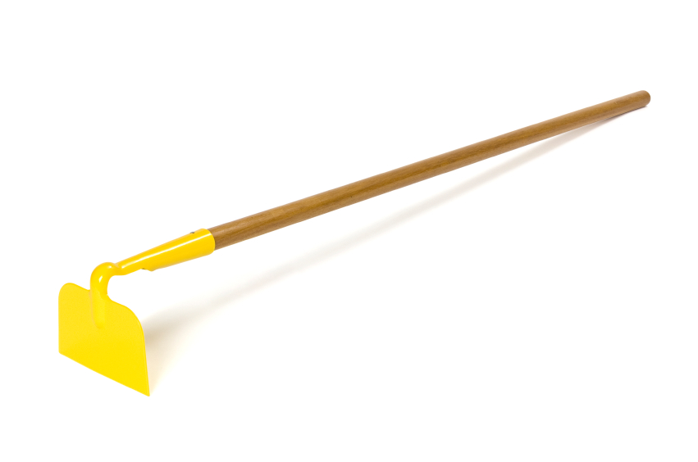


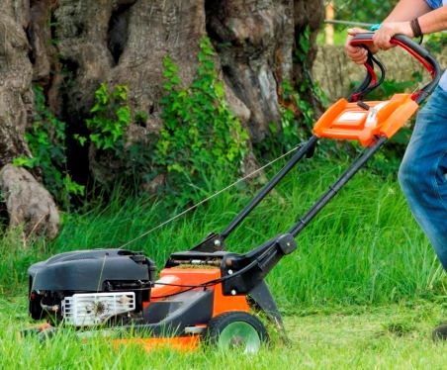



Resource 2 - What are they doing?

Match the words to the picture
b

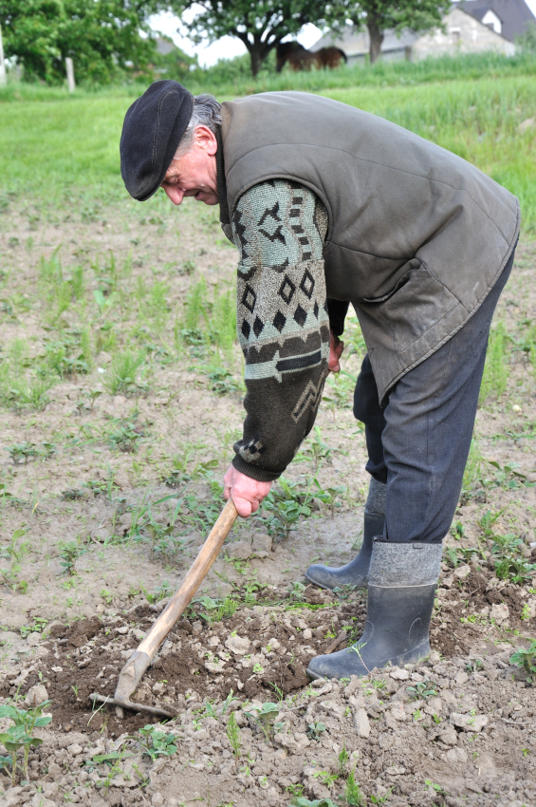

a

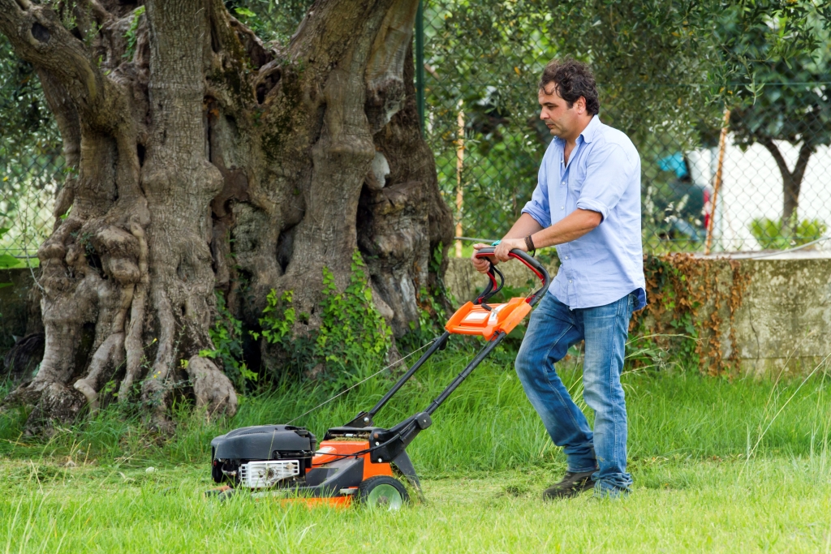
d
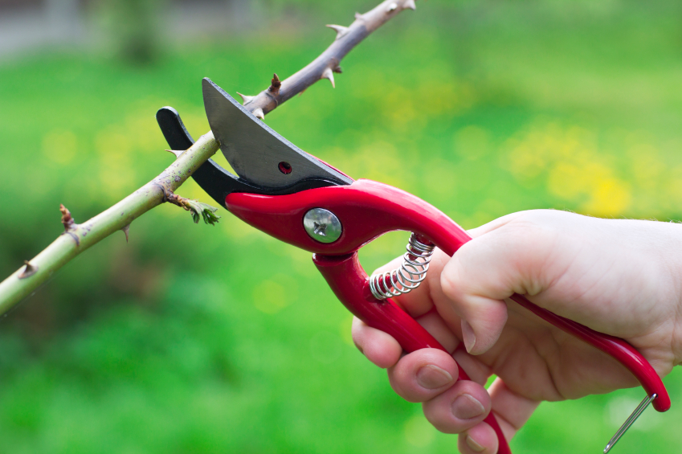

c

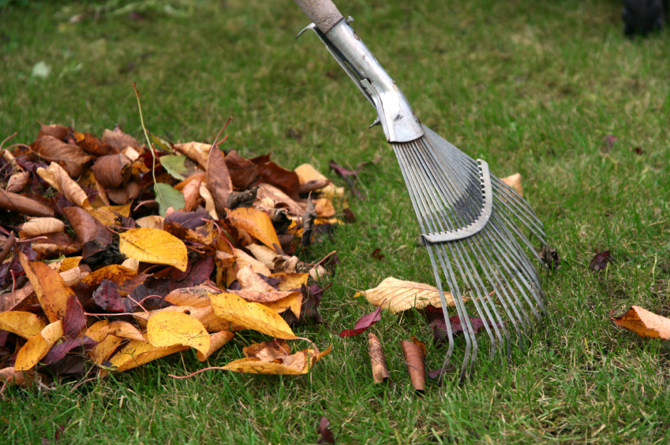
e f


mowing raking watering pruning digging hoeing

Resource 3 Tool Purpose - Tick the correct answer
Question 1  You use a hoe to |  |  | 
answer□  to mow | answer□  to weed | answer□  to water
Question 2  You use a lawnmower to |  |  | 
answer□  to cut grass | answer□  to water plants | answer□  to prune plants
Question 3  You use a trowel to |  |  | 
answer□  to prune plants | answer□  to water plants | answer□  to dig
Question 4  You use secateurs to |  |  | 
answer□  to mow | answer□  to prune | answer□  to dig
Question 5  You use a watering can to |  |  | 
answer□  to weed | answer□  to prune | answer□  to water

Resource 4 Questionnaire

Ask four people in your class what they like doing. = yes
X = no

Name | Do you like  working outside   |   Do you like | Do you like   |   Do you like
Jon |  | X

Resource 5a Planting Seeds Put these words in the correct order to make sentences and then put the sentences in order.

sunny a seed tray in place the Put

surface Press flat compost so the is
tray compost seed Fill with a

seeds Sow

with Water gently a watering can

seeds Cover compost with

Resource 5b – Planting Seeds


Sow seeds
Press compost so the surface is flat.
Water gently with a watering can
Cover seeds with compost
Put the seed tray in a sunny place
Fill a seed tray with compost

Resource 6 a– Listening Activity
Listen to the audio and answer the questions.
- What class is this?
___________________________________________________
- Keep your _________________ _____________ with you at all times.
- Where is the tool shed?
___________________________________________________
- Name two vegetables that need to be planted?
_________________________________________________________
5 What will the students do after planting the vegetables?

6 What must you not be when working in the gardens?
_______________________________________________________


cabba
The teacher is talking about..... |  |  | 
working in the kitchens □ | working in the gardens□ | working on the wings □
Students must go to the ........ to take off their shoes |  |  | 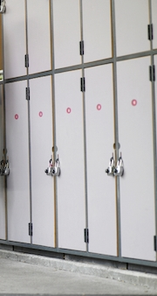
tool shed □ | greenhouse □ | locker room □
The tool shed is next to .......... .. |  |  | 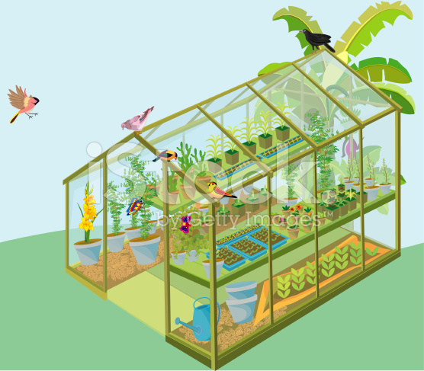
The locker room□ | The garden workshop □ | The greenhouse □
What vegetable was talked about? |  |  | 
beans □ | cabbages □ | broccoli□
I don’t want to hear anyone saying they’re |  |  | 
sad □ | happy □ | bored □
Resource 6b. Listen to the audio and tick the right answer.
Resource 7a – Imperative verbs

dig | weed
plant | mow
sow | put
water | prune

Resource 7b
Choose the correct word from each box to write instructions for making a cup of tea.
Find
Drink
Watch
a mug
1 6
the hot water into the mug
Pour
Drop
Drive

2
a teabag in the mug

Go
Look
Put

the teabag if you want

Remove
Tidy
Watch

7

3
some water in the kettle
Fill
Use
Put

8
sugar if you want
Take
Add
Leave

4
the water
Find
Boil
Put

5 Enjoy!
some milk into the mug
Pour
Drop
Drive

Resource 8 – Imperatives to give advice
- I have to cut the grass. What should I use?
- There are a lot of leaves on the lawn. How can I remove them?
- It’s very hot and my plants are dying. What can I do?
- I have to prune my tree. What can I use?
- There are a lot of weeds in the vegetable garden. What should I use to remove them?
- My plant is too big for its pot. What can I do?
- I have legal visits for the next 2 weeks so will miss my horticulture class.

Resource 9a Reading –Working in horticulture


Hi, I’m Andy. I teach horticulture to prisoners here at HMP Pinewood. I tell my learners to study horticulture so they can get a job. There are lots of jobs you can do.
- Work in a garden centre or for a company, mowing lawns and cutting hedges.
- Start up your own business doing gardening work. Local councils have a works department that cut trees and mow verges by the roadside. They also look after all the public parks, mowing the grass and planting up the flower beds.
So here are a few tips to help you get a job in horticulture.
- Write a good CV. Include in it all the garden work you did when you were in prison. If you can use a lawnmower, say so. It means your employer won’t have to spend time and money teaching you.
- Get a qualification. The horticulture course is long, but you will have a qualification that you can use outside.
- Use the VC, if you have it at your prison, to look for horticultural jobs.
- Make a note of the companies who are advertising and write to them when you are out.

I hope this helps and you find a great job that you enjoy.

- List 3 gardening jobs you can do when you leave prison.
- What gardening jobs can you do if you work for the local council?
- What are verges? a) plants
b) grass edges by the side of a road
c) animals
- Underline all the imperative verbs in the text.


Resource 9b – Working in horticulture
Read the text and answer the questions
Hi, I’m Bart and I’m a prisoner at HMP Pinewood. I work in the ________ and I’m studying__________________. It’s very busy at the moment because it’s summer and everything is growing. This is what I have to do this week.
- Plant out the ______________
- Dig up the daffodil bulbs and put them in the bulb box.
- Weed the border by the kitchens.
- Mow the _______________
I like working outside. I want a gardening job when I leave.




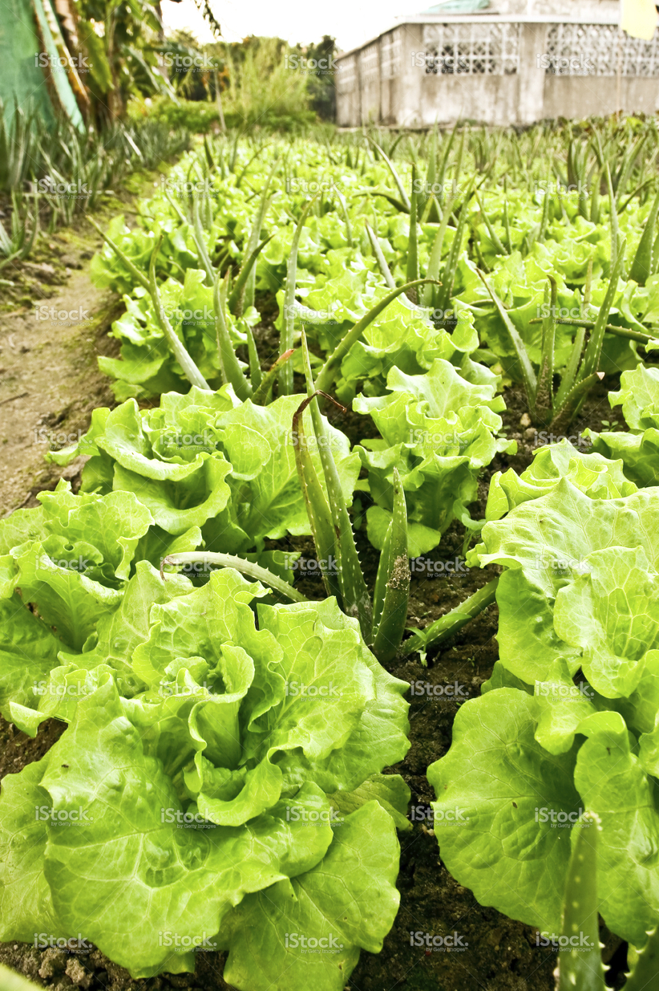
Hi, I’m Bart and I’m a prisoner at________. ___ I work in the gardens and I’m studying Level 2 in horticulture. It’s very busy at the moment because ________ and everything is growing. This is what I have to do this week.
- Plant out the lettuces.
- Dig up the ___________ and put them in the bulb box.
- Weed the _________________.
- Mow the lawn.
I like working outside. I want a ___________job when I leave.


Word search

s | f | l | d | p | h | n | p | g
e | c | g | j | r | x | b | l | t
c | v | g | a | u | l | e | o | f
a | r | r | h | n | s | b | t | e
t | v | o | d | e | p | a | i | x
e | i | w | s | e | e | d | s | w
u | d | i | g | g | i | n | g | e
r | h | n | c | a | i | n | f | e
s | b | g | o | a | i | r | w | d
h | o | e | e | r | n | l | t | i
c | r | t | e | y | w | c | k | n
e | s | t | m | o | w | a | g | g
c | a | e | t | r | o | w | e | l
w | p | c | o | m | p | o | s | t

secateurs hoe trowel weeding seeds digging plot prune mow growing watering compost

